**PROCESS FLOW DIAGRAM**

# **Summary**

## **Process Flow**

1. PHP pull data from database
   1. Data can monitor in COGNOS
   2. Finance 🡪 E-Invoice
2. YGL Server (168.168.190.240) Task Scheduler(4pm) run Bash Script
3. Bash Script runs PHP URL to generate CSV file with FTP(FileZilla)
4. Generated file can be found in
   1. \\168.168.190.248\Share\eInvoice\Import

## **Invoice Type**

Each PHP file handles a specific type of invoice. (Purchase invoice excluded)

4 Types of Invoice will be generated

1. Sales Invoice
2. ARCNDN
3. Self-billed Invoice (Purchase Invoice)
4. APCNDN

|  |  |  |  |  |  |
| --- | --- | --- | --- | --- | --- |
|  | Sales | | ARCNDN | Purchase Invoice | APCNDN |
| Php file | Sinvoice.php | | ARCNDN.php | Pinvoice.php | APCNDN.php |
| PICInvoice.php |
| PinAddCost.php |
| Infor LN Invoice Type | Normal | S01 | SCN,SDN | PIN | PDN,PCN |
| Manual | S02 | S10 | PIC | PCC |

# **General Script Flow**

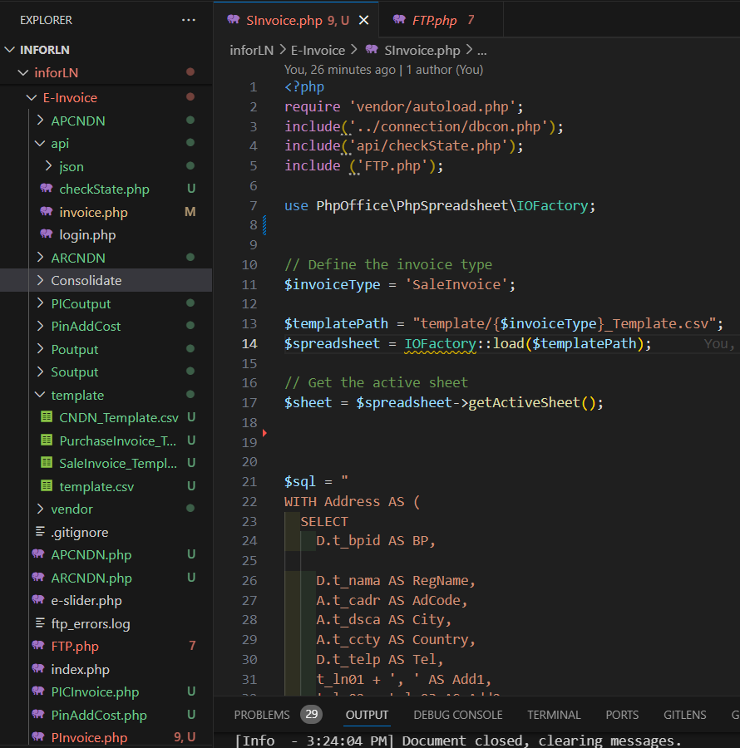

## **include('api/checkState.php')**

|  |  |
| --- | --- |
| getStateCode($city) | standardizePhoneNumber($tel); |
| Converts State name to code to fit LHDN format | Converts Phone no. to code to fit LHDN format |
| Will remove after Finance standardize input format in Infor LN for easier execution |

## **include ('FTP.php')**

|  |  |
| --- | --- |
| createMemoryStream($spreadsheet); | uploadToFtp($memoryStream, $ftpFilePath); |
| Stores the result in memory | * Writes result into CSV * Use FTP method to generate the CSV in YGL server |

## **Template**

$invoiceType = 'SaleInvoice';

$templatePath = "template/{$invoiceType}_Template.csv";

To Fetch template file from Template folder

## **Use CSV**

use PhpOffice\PhpSpreadsheet\IOFactory;

$spreadsheet = IOFactory::load($templatePath);

$sheet = $spreadsheet->getActiveSheet();

For generate CSV file use

$sql contain query

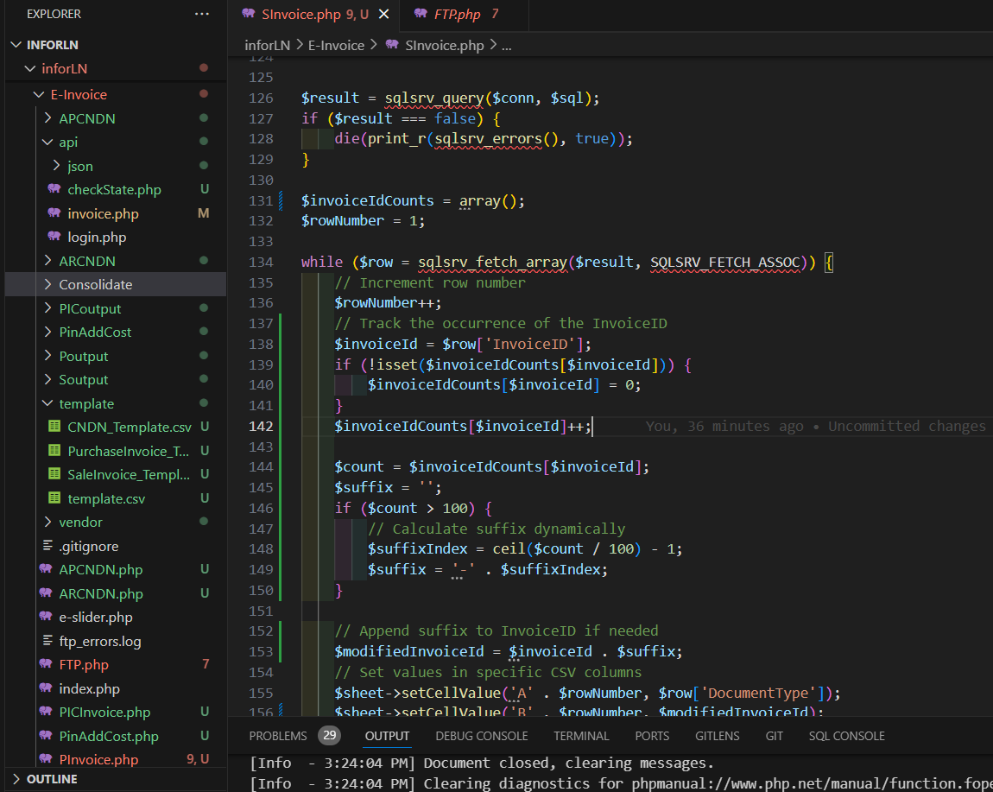

Stores the query to $result

## **InvoiceID Suffix**

$invoiceIdCounts = array();

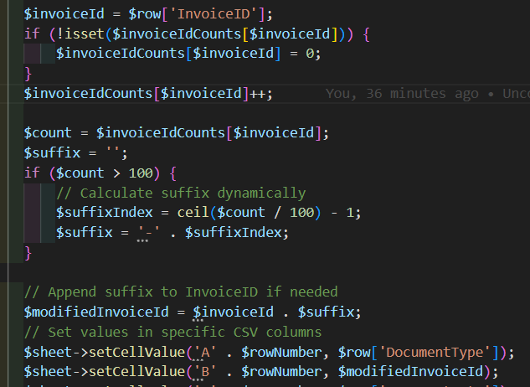

This part of the Code keeps tracks of the occurrence of InvoiceID as it represents number of item in an Invoice, LHDN only allow 100 item per invoice. If item over 100, the script with add suffix the invoice id.

Example if 250 items

|  |  |  |
| --- | --- | --- |
| 1st 100  1-100 | 2nd 100  101-200 | 3rd 100  201-250 |
| InvoiceID | InvoiceID-1 | InvoiceID-2 |

**Value Placement**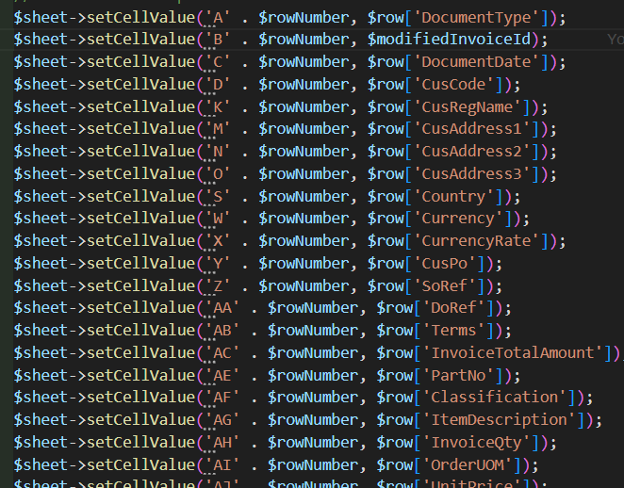

Query result will write into the CSV based on the designated columns

example



Column C = Col 3

Function from checkState.php

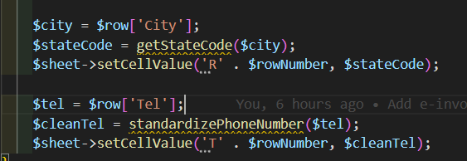

Declare filename and path and calls the [FTP.php](ftp://FTP.php) function to generate CSV file with FTP in YGL server

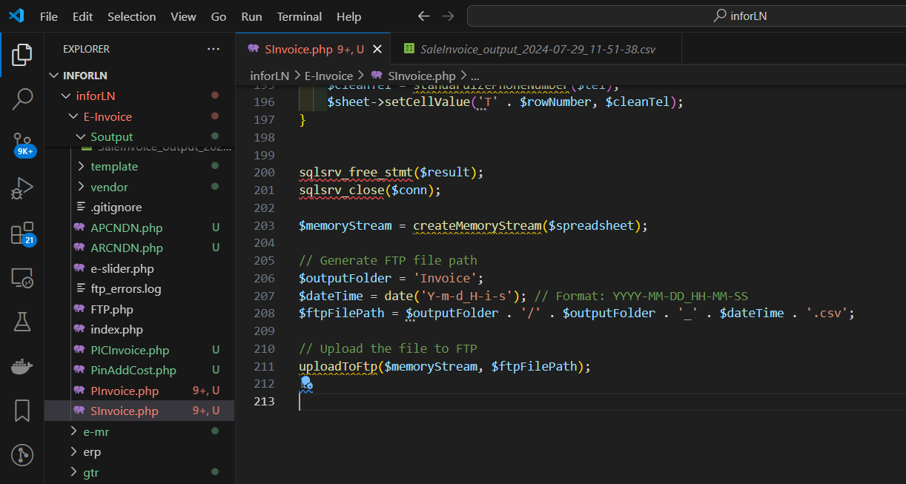

# **Query Details**

## **Sales Invoice**

